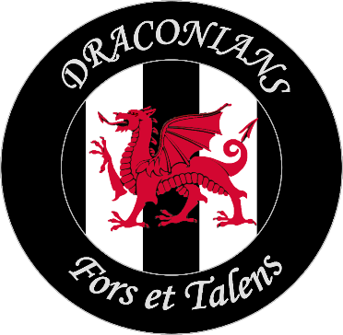

Community Consultation January 2025
At the Heart of the Community
Subject – the Development of facilities and support for the community at Lydstep Park, Gabalfa, Cardiff.
Cardiff Draconians F.C. are looking to develop its facilities at Lydstep Park to help support the wider community as well as promoting the game of football through greater participation for local residents.
The club are hopefully heading towards the Tier 2 of the Welsh football pyramid, which will require better facilities at Lydstep park which is in the heart of the Community.
Methodology – Throughout the month of January a Community Consultation has been rolled out across the Gabalfa area with local residents. Access to the Community Hub, Gabalfa Youth wing, local schools, Cathedral View Surgery as well as spectators at the home football match as well as door to door. The use of questionnaires have been distributed in paper form as well as on-line.
This report is compiled as of 28th January in a timely manner with a view to time scales required for the development process at Lydstep Park, well will continue to collect more feedback from residents in the coming months.
Response – the following data was recorded.
- 97 people responded, (31 female, 52 male)

- Ages of Participants: Ages 10 – 16 = 21 Ages 17 – 25 = 14 Ages 26 to 55 = 33 Age 55+ = 29

- Stated number of people in education = 34

- Stated Health of participants: Excellent Health = 36 Good Health = 36 OK = 11 On Medication = 7 Poor Health = 5

- Stated Fitness of Participants: Excellent = 26 Good = 42 Average = 224 Poor = 1

- Stated participation in sport: 54 people stated that they participated in sport (some participated in a number of different sports)
Football = 41
Jogging/running = 6
Walking = 5
Rugby = 5
Gym/Fitness = 8
Yoga = 2
Netball = 3
Boxing = 3
Golf = 2
Cricket = 4
Badminton = 2
Baseball = 3
Cycling = 2
Swimming = 2
Single responses to the following sports were entered: Bowls, Skittles, Tennis, Karate, Aerobics, Kickboxing, Hockey, Paddle ball, Darts,

- Stated participation in community activities:
19 respondents stated yes.

Respondents stated that the following facilities would be welcomed at Lydstep park:

Types of Community activity at Lydstep Park what would be welcomed at Lydstep Park:

The following comments were made on the consultations:

- Leisure Centre really needed; we are isolated here due to western Avenue (A48).
- Skate Park
- Education, health & wellbeing and community gathering important in building
the community.
- Youth action needed (x 5 people) as well as keeping them off the streets.
- Keep fit for over 60s, youth club with snooker, table tennis and dance.
- A community meeting place, multiple sports clubs, wellbeing, coffee mornings
- No social networking opportunities.
- More activities for older people (not only bingo) Litter picking programme (x3 people).
- 3g Floodlit football pitch (x 4 people)
- Cardiac Rehabilitation
- Multi sports complex (x 2 people)
- Veterans football.
- Women’s toilets.
- I am all for development of Lydstep Park / facilities.
- Swimming Pool, access to clean cold-water swimming

